8/23/2019

Daniel McCracken

WEB601 Dynamic web technology

WEB601

Milestone 1

Table of Contents

**1** **Introduction** 2

**2** **Analysis and Information Gathering** 2

**2.1** **Website Purpose** 2

**2.2** **Website Goals** 2

**2.3** **Target Audience** 2

**2.4** **Why Will People Use My Website** 3

**2.5** **How Will People Find My Website** 3

**2.6** **User Personas** 3

**2.7** **User Scenarios** 3

**2.6** **Competitive Analysis** 4

**3** **Planning** 4

**3.1** **Site Content** 4

**3.1.1** **Content and Functional Requirements** 4

**3.1.2** **Group and Label Content** 5

**3.2** **Site Structure** 6

**3.2.1** **Metaphor Exploration** 6

**3.2.2** **Site Structure Listing** 7

**3.2.3** **Architectural Blueprints** 7

**3.2.4** **Define Navigation** 7

Local 7

**4** **Design** 7

**5** **Working Prototype** 7

**6** **Appendices** 8

**6.1** **Appendix 1 – Personas** 8

**6.2** **Appendix 2 – User Scenarios** 0

**6.3** **Appendix 3 – Competitive Analysis Worksheet** 2

**6.4** **Appendix 4 – Label Content** 3

**6.5** **Appendix 5 – Sitemap** 4

**6.6** **Appendix 6 – Site Structure Navigation** 0

**6.7 Appendix 7 – Wireframes** 0

**7** **References** 5

# **1 Introduction**

This project will be to design an open website which allows new music artists to upload their works to an online base for the community to browse. Those browsing could potentially be scouts from music companies after new musical talents. The website will include the ability for users to upload and edit their existing music and for other user to browse through sons that artists have made available. The goal is to build this into a community-based website to help new singers start out and potentially even other musical artist even those who do instruments.

# **2 Analysis and Information Gathering**

## **2.1 Website Purpose**

The website will exist to provide a base in which people who are trying to start out in the music industry can upload their works for others to listen to and share.

There will be both a browse and search function for listeners to browse through available songs. On the flip side there will be an upload music and my music sections to allow the website to fulfil its other purpose.

## **2.2 Website Goals**

The short-term goals for this website are to provide an open environment in which new music artists feel comfortable sharing their works to the community. This could will also give a collection of talented individuals that scouts from music companies can consider for their businesses. This site will give these scouts that single location they need to search out talented musicians.

Longer-term goals will be to create a social area where artists can provide advice to each other and gain help in furthering their careers and perhaps an event area where regular events can be held for musicians to showcase their works. Long term the financial side of the website will need to be considered. The aim is to make the website a free, open space for users though it will need to pay for itself. Perhaps adding advertisements could be a source to consider.

## **2.3 Target Audience**

This website is aimed at a younger generation, people 15-30 years old. This is the best age range to consider for a website designed to promote the music of people new to the musical industry and wanting to become known for their songs.

The audience targeted are those who have a passion for music but are unable to find a way to enter the industry. This website is all about giving potential talented artists a chance to shine in a music industry which is so difficult for new artist to make their way in.

Another audience will be scouts from music companies seeking out new music potential. This website will provide a base for many talented individuals allowing these scouts a single place to go to in their search.

## **2.4 Why Will People Use My Website**

For starters it will be a free open zone freeing new artists from using large amounts of their personal funds to make a start in the industry.

Secondly, it will attract scouts form music companies due to having many talented individuals in the one place to reach out to.

## **2.5 How Will People Find My Website**

Helping users to locate my site is an important part in the planning. To this end partnering with other music companies and websites will provide one means of users finding us. The other intended means of bringing users to the website is by using social media to promote it and what it has to offer.

The primary action intended for users to take is to upload their music. A close second will be users using the browse/search functions to try out various songs.

## **2.6 User Personas**

Personas have been created for the two key audiences this website is intended for, new artists and scouts for music companies. These are located in Appendix 1.

## **2.7 User Scenarios**

User scenarios have been created for each of the above user personas. These are located in Appendix 2 and are based on the following scenarios.

Scenario 1

Tusara is a young woman passionate about here music and wanting to make a career out of it. However, the music industry is a field which is most difficult for new musicians to carve a niche into. She has heard of a free website with a friendly community known for supporting new musicians in kick starting their careers and takes a look.

Tusara lands on the home page and immediately sees a line of text advertising the sites purpose with a call to action button inviting her to upload her music.

Tusara clicks on this button which will bring up a screen inviting her to create a free account to start uploading her music for the community to see. Upon creating her account Tusara will be taken to the upload page allowing her to begin adding her songs to the website.

Upon uploading a number of her songs Tusara would like to see her songs and perhaps make some changes. She looks for her music by clicking on her profile icon. Upon seeing the ‘my music’ menu link Tusara clicks on this and is taken to the page containing her music.

Scenario 2

John is a middle-aged man working for a music company. His role is to seek out talented individuals who would be a boon to his company. He has recently learned of a website allowing music users to upload their music for free for the community to listen to. John see this as an excellent place to scope out new musicians.

John lands on the landing page and immediately sees the line of text stating the sites purpose and the call to action. The call to action does not interest him, however he next sees a ‘browse music’ menu item which is what he is after and clicks on this.

John is taken to the browse music page which displays for him popular songs along with a button on each to play the song. He clicks a play button and listens to the song.

## **2.6 Competitive Analysis**

An analysis has been conducted with a Competitive Analysis worksheet constructed based on the results. This can be located in Appendix 3.

# **3 Planning**

## **3.1 Site Content**

### **3.1.1 Content and Functional Requirements**

Landing Page – this will have a feature image overlaid with a line of text and a call to action button. This will be tailored for and targeted to users wanting to start uploading and promoting their music. Below will be a search function allowing users who are after particular songs or artists to search for them rather than browse.

Following these is a section to display popular songs or artists because many users do not get past the first page of a website and this is intended to pique their interest in what is currently popular.

Browse Music – similar to the landing page this will also feature popular songs or artists. However, because it is a browse page a side bar containing categories will be a part of the page allowing users to filter music out by the different types of categories.

Login – At the moment this is a page however due to a suggestion from my tutor I might see if I can make it a pop-up window instead. Either way the functionality of this is to allow users to login to their accounts through the insertion of their username and password. After logging in new options will become accessible in place of the login and sign up buttons. These will be accessed through a profile image with a drop-down menu.

Sign Up – I this will function the same way as login except it contains fields where the user will enter new details for the system to record rather than existing ones for the system to check. Signing up will automatically log the user into the new account and same as the login will provide the user additional options accessed via the profile image.

Upload Music – this will only be accessible to a user when they are logged into an existing account. This panel will all a user to drag their music files into the window for upload or browse their documents. Upon a successful upload the new songs will appear in the ‘my music’ page.

My Music – this will function as a page allowing the owner to access all their uploaded music from one spot and categorize them. This will only be accessible if the user is logged in. It will have a sidebar with the various categories though this functionality will be a future addition and it will display a range of music allowing the user to view what they have uploaded.

My Account – this page will function as an area where the account owner can view and change their personal details. The user must be logged in to access this area. It will contain editable fields showing the users current details and allowing them to edit then confirm the changes.

Support – this will be a window where a user can enter their details and leave a message to get support from the website. It will contain fields for personal details and a message box.

Search Results – this will display a list of songs retrieved by the search function and displayed to the user. A possible future addition I could add if time permits is a sort function to enable the user to sort the results for easier location of songs.

### **3.1.2 Group and Label Content**

Content labels are important for both helping a user to scan the site as well as for SEO knowing what the content of the website contains. As a result, labelling content well is vital part of a web developers job.

Content labels include:

* Headings
* Subheadings
* Taglines
* Image headings and captions
* Video headings and cations

It is important that each page contains an h1 heading and possibly a supporting tagline. As many people will instinctively look for these. And even more importantly having these is crucial to getting good SEO rankings.

Same with videos and images. Labels enable search engines to know what the image or video is about and additionally they allow user who are unable to view the image or media to know what it is.

As for the grouping and organisation of my content I will it will not be difficult with the site I am developing as most of it will be music and this will be having future categorization added to it to enable users to browse smoothly through it. Grouping will also come into effect if I add the sort by capability to the search result page.

A chart labelling my websites content can be located in Appendix 4.

## **3.2 Site Structure**

### **3.2.1 Metaphor Exploration**

Organizational Metaphors

This refers to how things are organized with a website. Most people have a mental image of how a website will be organized and instinctively look for various buttons and functions in specific areas of the screen. When creating a website, it is good to keep with what is expected as doing otherwise may cause users to spend time looking for things if they are not where they are expected and as a result leave the website for one of its competitors. I have tried to keep all of my websites components where they are expected to be to make the experience of all users as easy and efficient as possible.

Functional Metaphors

Icons and other shaped buttons are a good example of functional metaphors. They show what it is meant to do so that user of the website knows what they are doing or where it will take them when they click on it. One area I will be using this in in the profile image this will represent a user’s profile/account in the website. Other areas will be the use of social media icons placed in the footer, a search icon beside the search bar perhaps a folder icon in the upload screen, and I haven’t actually put it in my wireframes and mock-ups but I am considering putting a music note icon beside each song which will represent it as music.

Visual Metaphors

This is using the visual aspect of a website to make it appear as something other than a website of texts and images. For instance, some websites such as some digital book ones make the screen appear as a book and act like one etc. The closest I will be getting to a functional metaphor in my website will be using colours and images to give a music feel to it.

### **3.2.2 Site Structure Listing**

For the site structure listing I have created a sitemap mapping out the website’s navigation. This can be located in Appendix 5.

### **3.2.3 Architectural Blueprints**

I have created a diagram showing the structure of navigating back and forth between the various web pages that make up the website. This diagram can be located in Appendix 6.

### **3.2.4 Define Navigation**

#### Global

This is the top-level navigation visible on all pages which in relation to my website is the navigation menu along with ‘my account’ sub-menu.

### Local

This is all links which come from the web pages body and link to another page on the website. This could be hyperlinked text or buttons within the body, etc. In relation to my website these will include the two calls to action on my landing pages as well as the promoted popular music and artists. These will have links taking the user to the specific song or artist. Apart from these I do not really have any short-term plans for much local inking as of yet.

# **4 Design**

A wireframe has been created for each page I will develop of the website. They are located in Appendix 7.

Wireframes are designed to represent a basic form of a website. A skeleton of it so to speak. They are basically a blueprint, a visual guide to how the developer is planning on structuring the pages and content.

# **5 Working Prototype**

This can be located in my GitHub repository by using the following link:

<https://github.com/DanielM-IT/WEB601_Project_Art_of_the_Tune>

# **6 Appendices**

## **6.1 Appendix 1 – Personas**

|  |  |
| --- | --- |
| **Persona 1** | |
| selective focus photography of man leaning on table | **Name:** John Smith  **Gender:** Male  **Age:** 38  **Lives:** Auckland, NZ  **Married:** Wife and two children  **About:** Spends his life between work and family. Is passionate about seeking out and encouraging musical talent.  **Employment:** A&R Scout |
| **Stage of life** | Very family-oriented guy wanting to provide for them as best as he can. |
| **Level of engagement** | Regular usage of media and other websites both for work and at home |
| **Digital skills** | High level of knowledge and experience in the musical industry. |
| **Dominant skillset using Social Media** | Very active in posting own content and leading several social media communities. |
| **Motivation and desires** | Wants to give to the musical community and see other artists succeed. |
| **Frustrations and**  **barriers** | Working long hours leaving only short amounts of personal time. |
| **Unique personality assets** | Extravert |

|  |  |
| --- | --- |
| **Persona 2** | |
| man standing near building during daytime | **Name:** Tusara Odere  **Gender:** Female  **Age:** 26  **Lives:** in Nelson**,** NZ  **Married:** Single  **About:** Likesto spend their free time singing and making up new songs accompanied with playing the guitar. Is very passionate about their music and is actively looking for a way to make a career out of it.  **Employment:** Working full time at the local supermarket. |
| **Stage of life** | Enjoying life and living every moment to its fullest |
| **Level of engagement** | Keeps up to date on all happenings through social media and other music blogs. |
| **Digital skills** | In the begging stages of learning to use sound mixers and other audio equipment. |
| **Dominant skillset** | Using voice and instrument to create own music. |
| **Motivation and desires** | Want to live life to its fullest and give it meaning. |
| **Frustrations and**  **barriers** | Unsure of the best means of making her love for music into a career. |
| **Unique personality assets** | Extravert |

## **6.2 Appendix 2 – User Scenarios**

# 

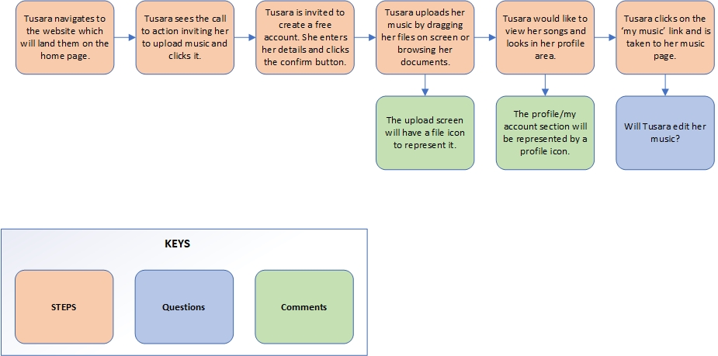

## **6.3 Appendix 3 – Competitive Analysis Worksheet**

|  |  |  |  |  |
| --- | --- | --- | --- | --- |
|  | Competitor A  Tunecore | Competitor B  CdBaby | Competitor C  SoundCloud | Personal Insight and Rationale |
| What Social Media platforms are being utilised? | Facebook, Twitter and Instagram. | Facebook, Twitter, Instagram and YouTube. | None. | The highest competition has all spread themselves out over multiple social media platform reaching a large audience, something to keep in mind. |
| Strength of connectivity to other marketing activities | They have connected themselves to Spotify, Apple Music, Amazon Music, Google Play Music and YouTube. | Spotify, Apple Music and YouTube. | Google Play and Apple Music. | Most of these competitors partner with the same companies. Most likely because they are the ones with the best audience reach. |
| How have they achieved accessibility or reach to identified target markets? | The focus appears be usage of a blog where they post at least bi-daily as well as regular posting across media channels and the holding of regular events. | Their regularity of posting and consistency of content choice shows they have a target audience in mind and are regularly holding events for their audiences. | They appear to be mostly reliant on Google Play and App Music for reaching their audiences. | It will be important to use social media on my website as well as I have thoughts on a possible future blogging system. |
| Evidence to suggest Social Media control mechanisms | They are disseminating between their platforms and they post at least daily so there is plenty of use in social media control mechanisms. | Definitely. They are posting no less than once a day on nearly all platforms. | No evidence at all. | If my company wants to do well then regular posting across social media platforms will go a long way to getting the website noticed. |

## **6.4 Appendix 4 – Label Content**

## **6.5 Appendix 5 – Sitemap**

## **6.6 Appendix 6 – Site Structure Navigation**

­­­

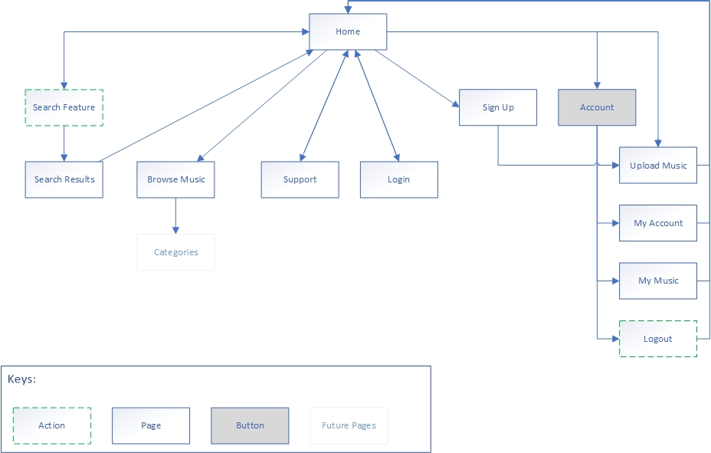

## **A screenshot of a cell phone Description automatically generated 6.7 Appendix 7 – Wireframes**

# **7 References**

<https://www.templatemonster.com/blog/metaphors-web-design/>

<https://www.interaction-design.org/literature/article/design-scenarios-communicating-the-small-steps-in-the-user-experience>

<https://www.oreilly.com/library/view/information-architecture-for/1565922824/ch08s02.html>

<https://marketingland.com/create-websites-nomenclature-labeling-system-online-findability-131130>

<https://www.usability.gov/get-involved/blog/2009/08/organizing-web-content.html>